
MATHEMATICS APPLICATIONS
Test 3 2018
Area, Surface Area, Volume and Similarity
Section A-Resource Free
Marks: 17 Time Allowed: 20 minutes

Total Marks: / 54
Name: _______________
ALL working must be shown for full marks.
Answers must be rounded to 2dp where appropriate

Question 1 [4 marks]
If a = 4 and b = -2

- 2a + 3b = b) 30 + ab =

c) 5(a – b) = d) a² + b² =

Question 2 [4 marks]
Convert the following units of measurement.

- 259000mm = m b) 0.042km² = m²

c) 6.5m³ = L d) 3500ha = km²

Question 3 [2 marks]
The triangular prism below has a volume of is 66cm³. Calculate the volume of a triangular pyramid that has the same base area and height as the prism below.
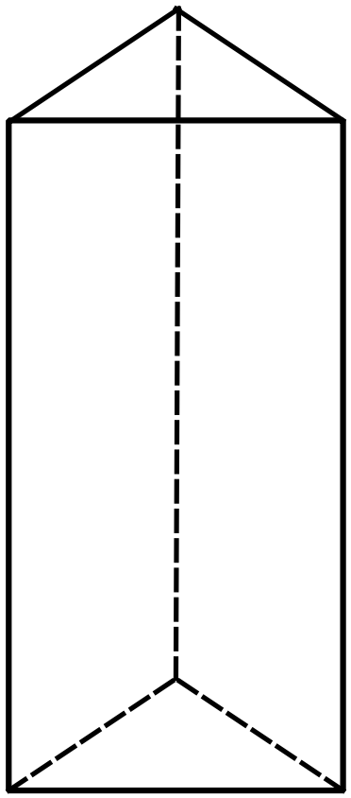

Question 4 [7 marks]
- Identify which pairs of triangles are Similar and state the similarity test that applies.
- Calculate the Scale Factor where the similar triangles occur.
- Give the value for the missing letters where the similar triangles occur.

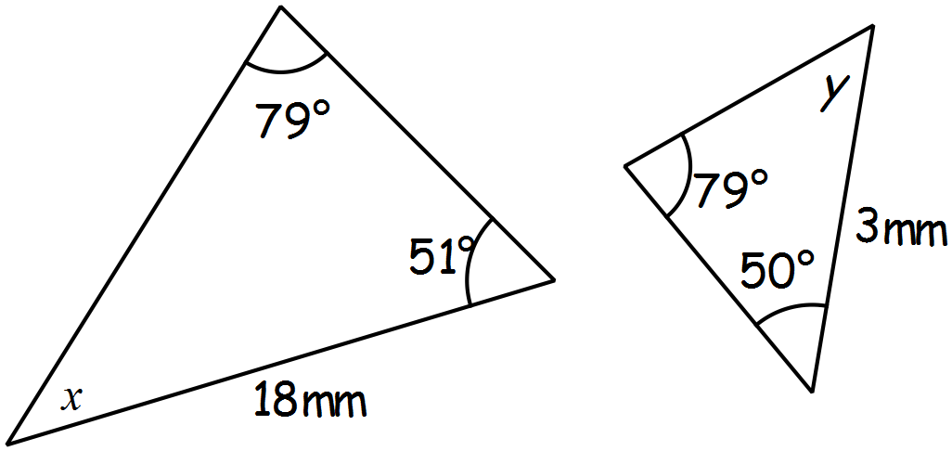i)

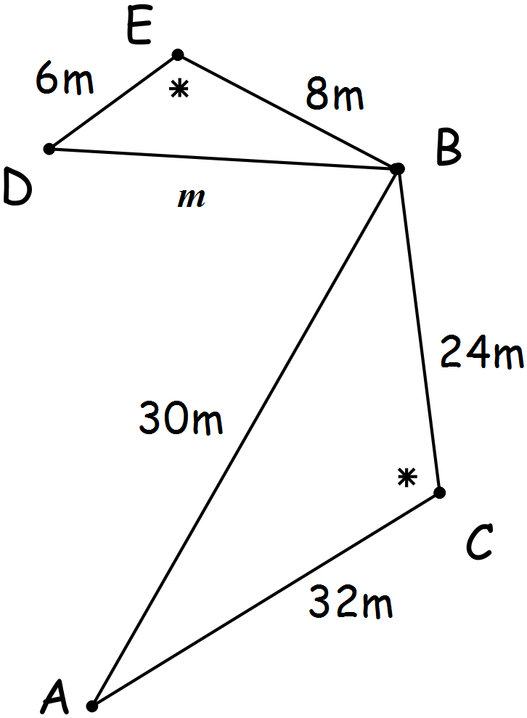ii)


MATHEMATICS APPLICATIONS
Test 3 2018
Linear Functions
Section B-Resource Assumed
Marks: 37 Time Allowed: 40 minutes

ALL working must be shown for full marks.
Answers must be rounded to 2dp where appropriate

Question 5 [1, 2, 2 = 5 marks]
For the following shape
- 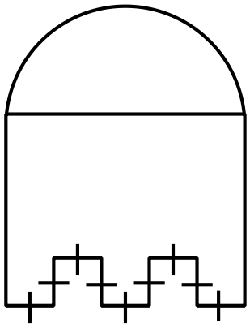Calculate the diameter of the semicircle

19cm

- Calculate the perimeter
4cm

- Calculate the area

Question 6 [3, 3 = 6 marks]
A cone has a volume of 24.74cm³ and a radius of 15mm.
- Calculate the height of the cone in mm.

- Calculate the total surface area of the cone.

Question 7 [2, 3, 5 = 10 marks]
The diagrams below show two possible plans for a garden outside a new medical center. The garden beds are shown in the diagrams as grey.

Diagram 1 Diagram 2
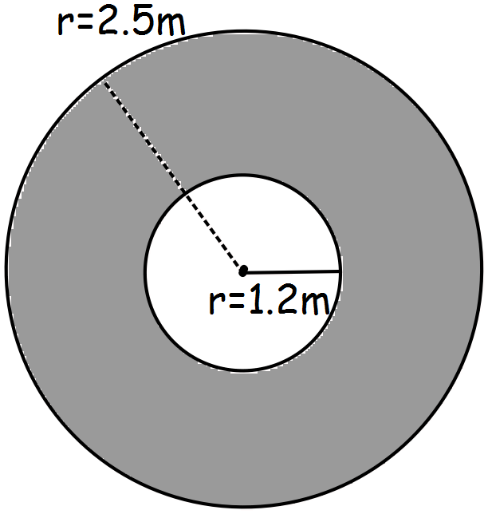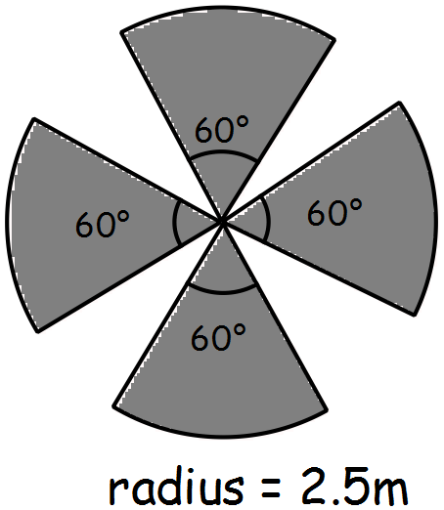

- Calculate the perimeter of each garden.

- A low fence is to be placed around each section of the garden which will cost $15 per metre for garden 1 and $20 per metre for garden 2. Use your answers from a) to calculate the cost of fencing the two gardens and decide the most cost effective design.

- If fertilizer costs $5.50 per square meter calculate the cost of keeping each garden healthy and state which garden will be cheapest to keep healthy?

Question 8 [1, 4, 2, 2 = 9 marks]
For the rectangular prism below
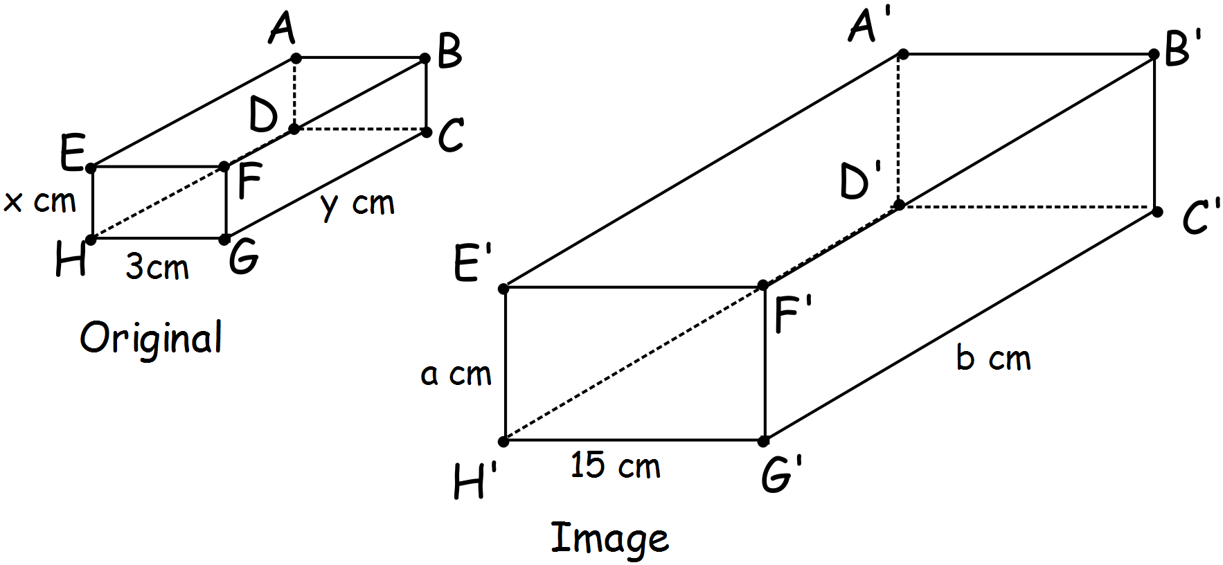

- Calculate the scale factor that has been used to produce the image.

- If the volume of the original prism is 24cm³ and each side is an integer (a whole number)

i) give the possible values for x, y

ii) from your values for x, y above, calculate a and b.

- If the volume of the original prism is 30cm³ calculate the volume and capacity for the image.

- If the surface area of the image is 1050cm², calculate the surface area for the original prism.

Question 9 [ 2, 2, 1, 2 = 7 marks]
The building plan for a doctor’s office is shown in the scale diagram below.
Answer the following questions relating to this plan.
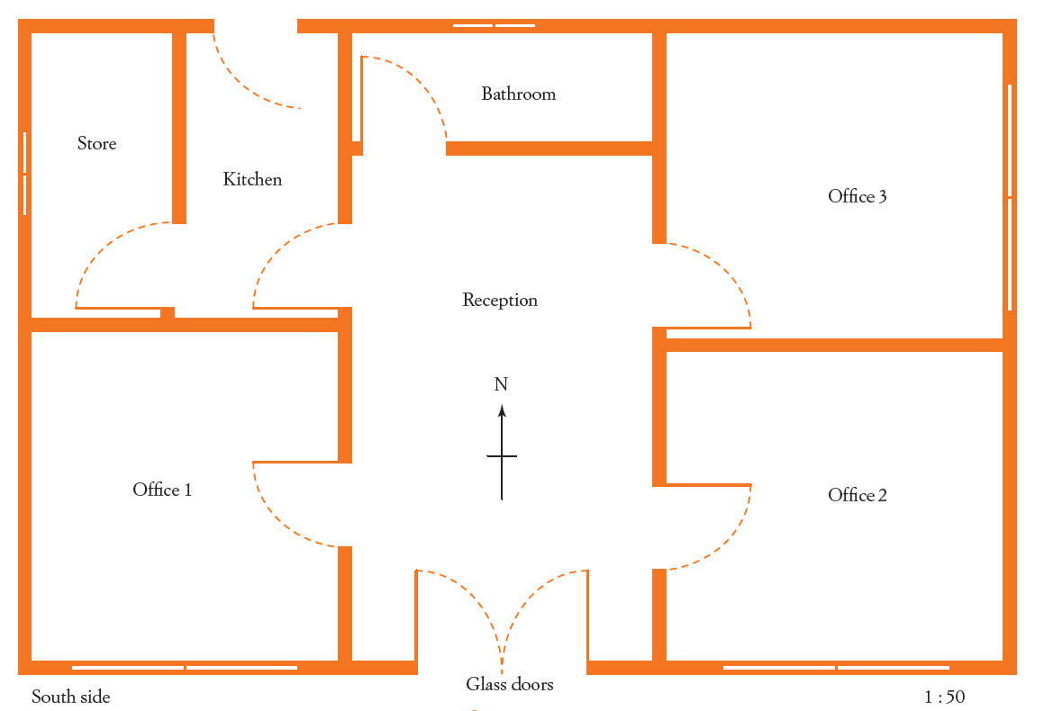

1:100

- Calculate the length and width for the real office building.

The concrete for the floor of the building needs to be 150mm thick.
- Find the volume of concrete needed to build the floor.

- If concrete costs $75 per cubic metre, calculate the cost of the concrete slab.

- Dr South would like his surgery in Office 1, he has selected the cheerful yellow carpet at a cost of $27.50 per square metre. Calculate the cost of carpeting Dr South’s office.

